Student Name: Click here to enter text.
Kit Code (located on the lid of your lab kit): Click here to enter text.
Pre-Lab Questions
”1. How do banding patterns change when a muscle contracts?”
Click here to enter text.
”2. What is the difference between a muscle organ, a muscle fiber, myofibril and a myofilament? ”
Click here to enter text.
”3. Outline the molecular mechanism for skeletal muscle contraction. At what point is ATP used and why? ”
Click here to enter text.
”4. Explain why rigor mortis occurs. ”
Click here to enter text.
Experiment 1: Tendons and Ligaments
Post-Lab Questions
”1. Label the arrows in the slide images below based on your observations from the experiment. ”
A- Click here to enter text.
B- Click here to enter text.
C- Click here to enter text.
D- Click here to enter text.
E- Click here to enter text.
F- Click here to enter text.

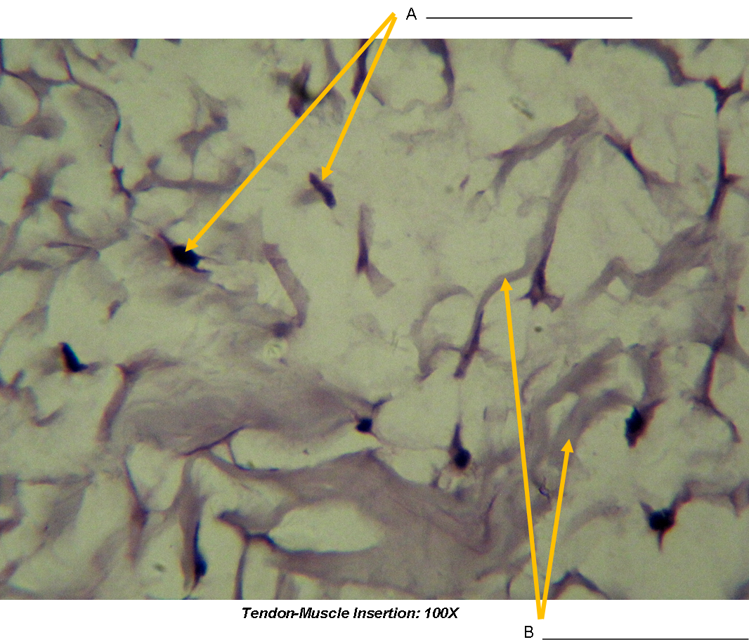
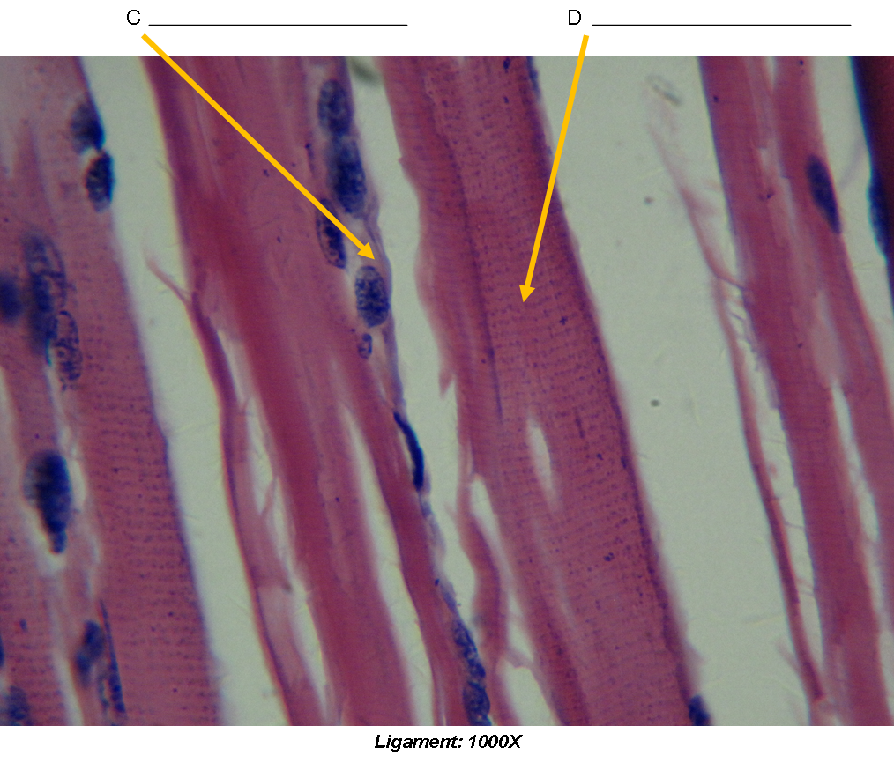

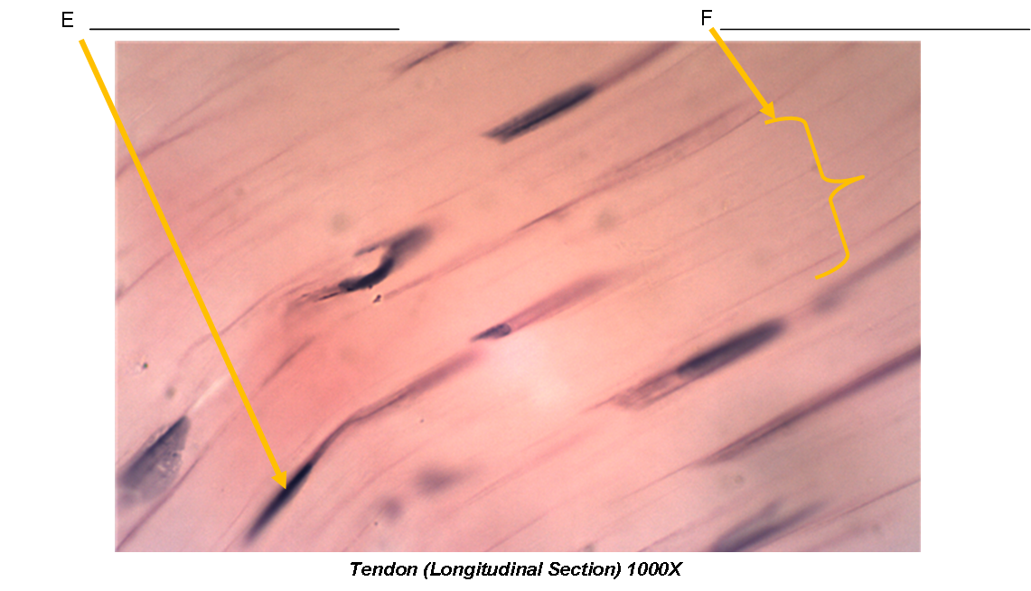

”2. How does the extra cellular matrix of connective tissues contribute to its function? ”
Click here to enter text.
”3. Why are tendons and ligament tissues difficult to heal? ”
Click here to enter text.
”4. What difference do you see between the tendon – muscle insertion image and the tendon image? ”
Click here to enter text.
”5. What differences do you see between the tendon and ligament sections? ”
Click here to enter text.

Experiment 2: The Neuromuscular Junction
Post-Lab Questions
”1. Are there few or many nuclei at the end plate? ”
Click here to enter text.
”2. What is a motor unit? ”
Click here to enter text.
”3. How is a greater force generated (in terms or motor unit recruitment)? ”
Click here to enter text.
”4. What types of sensors are present within the muscle to identify how much force is generated? ”
Click here to enter text.
Experiment 3: Muscle Fatigue
Table 1: Experimental Counts
 | Trial 1 | Trial 2 | Trial 3 | Trial 4 | Trial 5
Predicted Value | Click here to enter text. | Click here to enter text. | Click here to enter text. | Click here to enter text. | Click here to enter text.
Actual Value | Click here to enter text. | Click here to enter text. | Click here to enter text. | Click here to enter text. | Click here to enter text.

Post-Lab Questions
”1. How did the predicted results compare to the actual results? ”
Click here to enter text.
”2. Did you notice any changes in the number of repetitions you could perform, or how your hand felt after each of the trials? ”
Click here to enter text.
”3. Explain the actions that were occurring at the cellular level to produce this movement. Include sources of energy and any possible effect of muscle fatigue. ”
Click here to enter text.
”4. Hypothesize what would happen if blood flow was restricted to the hand when this experiment is performed. ”
Click here to enter text.
Experiment 4: Gross Anatomy of the Muscular System
Table 2: Gross Anatomy Data
Movement | Muscle(s) Activated | Action(s) of Muscle(s)
1. Forearm Extended (Step 1) | Click here to enter text. | Click here to enter text.
2. Fingers Extended and Splayed (Step 1) | Click here to enter text. | Click here to enter text.
3. Fingers Retracted (Step 1) | Click here to enter text. | Click here to enter text.
4. Forearm Pressed Down Upon (Step 2) | Click here to enter text. | Click here to enter text.
5. Elbow Bent (Step 3) | Click here to enter text. | Click here to enter text.
6. Arm Raised to Side with Heavy Object (Step 4) | Click here to enter text. | Click here to enter text.
7. Arm Extended Back with Heavy Object (Step 4) | Click here to enter text. | Click here to enter text.
8. Click here to enter text. | Click here to enter text. | Click here to enter text.
9. Click here to enter text. | Click here to enter text. | Click here to enter text.
10. Click here to enter text. | Click here to enter text. | Click here to enter text.
11. Click here to enter text. | Click here to enter text. | Click here to enter text.
12. Click here to enter text. | Click here to enter text. | Click here to enter text.
13. Click here to enter text. | Click here to enter text. | Click here to enter text.
14. Click here to enter text. | Click here to enter text. | Click here to enter text.

Experiment 5: ATP and Muscle Fatigue
Table 3: Muscle Fatigue Data
Trial | Time (seconds)
Trial 1 | Click here to enter text.
Trial 2 | Click here to enter text.
Trial 3 | Click here to enter text.

Post-Lab Questions
”1. What happened to the time intervals between Trial 1 and Trial 3? What caused this change? ”
Click here to enter text.
”2. Identify three muscles which were engaged during the wall-sit. ”
Click here to enter text.
”3. Explain the biochemical reasoning behind muscle fatigue. ”
Click here to enter text.
Experiment 6: The Virtual Model – The Muscular System (Upper Body)
Post-Lab Questions
”1. What is the scientific term for the muscles of the mouth? ”
Click here to enter text.
”2. Are the muscles used in deep mastication located on the ventral or dorsal side of the body?”
Click here to enter text.
”3. Do the m. pectoralis muscles belong to the deep thorax group or the superficial thorax group? ”
Click here to enter text.
”4. Is the m. rectus abdominis or the m. obliques externus more deep within the body? ”
Click here to enter text.
”5. Is the m. trapezius located in the abdomen, back, head, neck or thorax? ”
Click here to enter text.
”6. Which muscle lies directly posterior to the m. serratus posterior inferior right and left muscle groups? ”
Click here to enter text.

Experiment 7: The Virtual Model – The Muscular System (Lower Body)
Post-Lab Questions
”1. Is the extensor digitorum longus or the extensor digitorum brevis more superficial to the skin? ”
Click here to enter text.
”2. How many adductor muscles exist within the body? List them here. ”
Click here to enter text.
”3. Are the plantar muscles located in the foot, hip, leg, or thigh muscle group? ”
Click here to enter text.
”4. Does the lateral group of muscles extend towards the hallus or the fifth toe? ”
Click here to enter text.
”5. Which foot muscle group is most distal; the lateral group, the medial group, or the middle group? ”
Click here to enter text.

Experiment 8: Virtual Model – Muscular System Coloring Activity
”Upload images for each exercise below: ”
”Abdomen: ”


”Back: ”

”Head: ”

”Upper Limb: ”

”Lower Limbs (Posterior): ”

”Lower Limbs (Anterior): ”

”Lower Limbs (Anterior – Distal): ”

Experiment 9: Fetal Pig Dissection - Muscular System
Table 4: Experimental Data
Muscle | Origin | Insertion | Movement
Pectoralis major | Click here to enter text. | Click here to enter text. | Click here to enter text.
Latissimus dorsi | Click here to enter text. | Click here to enter text. | Click here to enter text.
Deltoids | Click here to enter text. | Click here to enter text. | Click here to enter text.
Rectus abdominus | Click here to enter text. | Click here to enter text. | Click here to enter text.
Transverse abdominis | Click here to enter text. | Click here to enter text. | Click here to enter text.
Gluteus medius | Click here to enter text. | Click here to enter text. | Click here to enter text.

Post-Lab Questions
”1. Describe the tissue that covers muscles. ”
Click here to enter text.
”2. How many layers of abdominal muscle are there? ”
Click here to enter text.
”3. What direction do the muscle fibers of the external oblique run? ”
Click here to enter text.
”4. Why are muscle fibers considered excitable? ”
Click here to enter text.
”5. Why is it important to have both flexors and extensors? ”
Click here to enter text.
”6. How can muscle mass be influenced by training or age? ”
Click here to enter text.

”Insert image of pig with skin removed with your name clearly visible in the background: ”

